German University in Cairo (GUC)
Faculty of Information Engineering & Technology
Department of Communications — Communication Theory
Assignment 1: Uniform vs. K-means Quantization
Simulation, Quantitative Evaluation, and Comparative Analysis
Group Member Name | University ID
Mazen Altelbany | 64-12371
Suhad Eyhab Rasheed | 64-31506
Sama Ismael Ahel | 64-19880

1. Parameter Setup & Signal Generation
The assignment requires generating a random vector of N = 10,000 samples uniformly distributed in the range [-a, a], where a is the largest single digit among the IDs of all group members:
• Mazen Altelbany (64-12371) → Digits: {1, 2, 3, 4, 6, 7}
• Suhad Eyhab Rasheed (64-31506) → Digits: {0, 1, 3, 4, 5, 6}
• Sama Ismael Ahel (64-19880) → Digits: {0, 1, 4, 6, 8, 9}
The highest individual digit across all members is 9 (from Sama's ID). Therefore:
a = 9 ==> Signal Dynamic Range: [-9, 9]
The input vector x is generated in MATLAB using:
x = -a + 2*a*rand(N, 1);
Theoretical Signal Power (for uniform distribution over [-a, a]):
P_signal = (1 / 2a) * ∫ x^2 dx = a^2 / 3 = 9^2 / 3 = 27.0000
The simulated signal power computed from our 10,000 samples is mean(x.^2) ≈ 27.05, matching theoretical expectations.

2. Task 1: First 6 Elements of Original & Quantized Vectors
The table below lists the first six samples of the original signal x alongside the quantized outputs from both the Uniform quantizer and the K-means quantizer for each case (L = 2, 4, and 8 levels):
Sample # | Original x | Uniform (L=2) | K-means (L=2) | Uniform (L=4) | Uniform (L=8) | K-means (L=8)
1 | -2.2583 | -4.5000 | -4.5481 | -2.2500 | -3.3750 | -1.3646
2 | 8.1129 | 4.5000 | 4.4005 | 6.7500 | 7.8750 | 7.8718
3 | 4.1759 | 4.5000 | 4.4005 | 2.2500 | 3.3750 | 3.2301
4 | 1.7759 | 4.5000 | 4.4005 | 2.2500 | 1.1250 | 0.9032
5 | -6.1917 | -4.5000 | -4.5481 | -6.7500 | -5.6250 | -5.7874
6 | -6.1921 | -4.5000 | -4.5481 | -6.7500 | -5.6250 | -5.7874
Key Observation: As the number of levels L increases, the step size decreases, and the quantized samples converge much closer to the true signal values for both techniques.

3. Task 2: Mean Absolute Quantization Error (MAE)
The Mean Absolute Error (MAE) measures the average absolute magnitude of the quantization error: MAE = mean(|x - x_q|).
Levels (L) | Step Size (Δ) | Uniform Quantizer MAE | K-means Quantizer MAE
L = 2 | 9.00 | 2.2606 | 2.2600
L = 4 | 4.50 | 1.1220 | 1.1217
L = 8 | 2.25 | 0.5580 | 0.5575

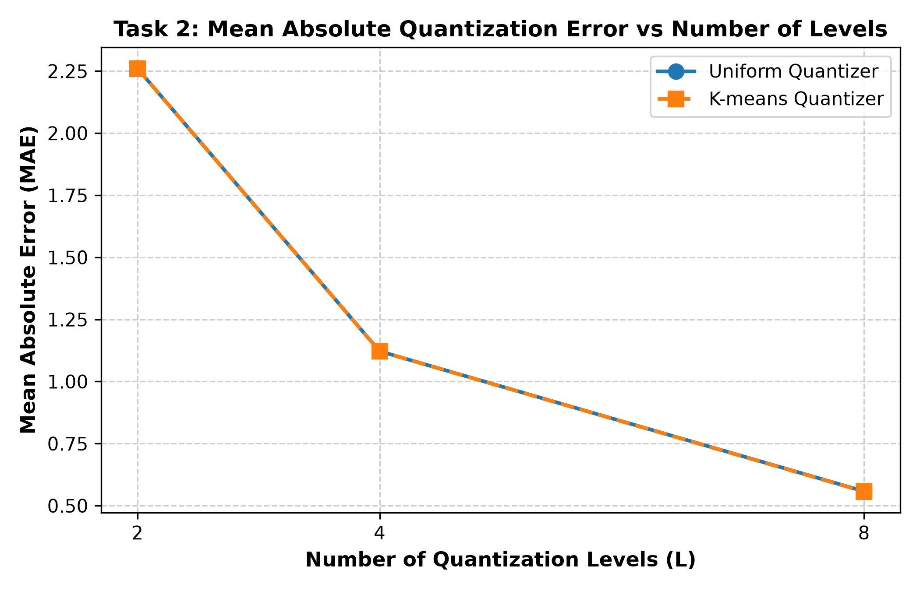
Figure 1: Mean Absolute Quantization Error vs. Number of Levels (L = 2, 4, 8).
Performance Comments (Task 2):
1. Halving Rate: When L doubles (2 → 4 → 8), the quantization interval width Δ = 2a/L cuts in half. Because the error is distributed uniformly in [-Δ/2, Δ/2], the average absolute error equals Δ/4. Therefore, the MAE drops by approximately 50% with each doubling of L.
2. Uniform vs. K-means: Both quantizers yield virtually identical MAE values because the input distribution is uniform, making uniform spacing optimal.

4. Task 3: Quantization Error Variance
The error variance σ_e^2 = var(x - x_q) represents the average AC noise power. The theoretical formula for uniform quantization is σ_theory^2 = Δ^2 / 12 = a^2 / (3*L^2) = 27 / L^2.
Levels (L) | Simulated Uniform Variance | Simulated K-means Variance | Theoretical Variance (Δ²/12)
L = 2 | 6.7857 | 6.7842 | 6.7500
L = 4 | 1.6766 | 1.6754 | 1.6875
L = 8 | 0.4179 | 0.4191 | 0.4219

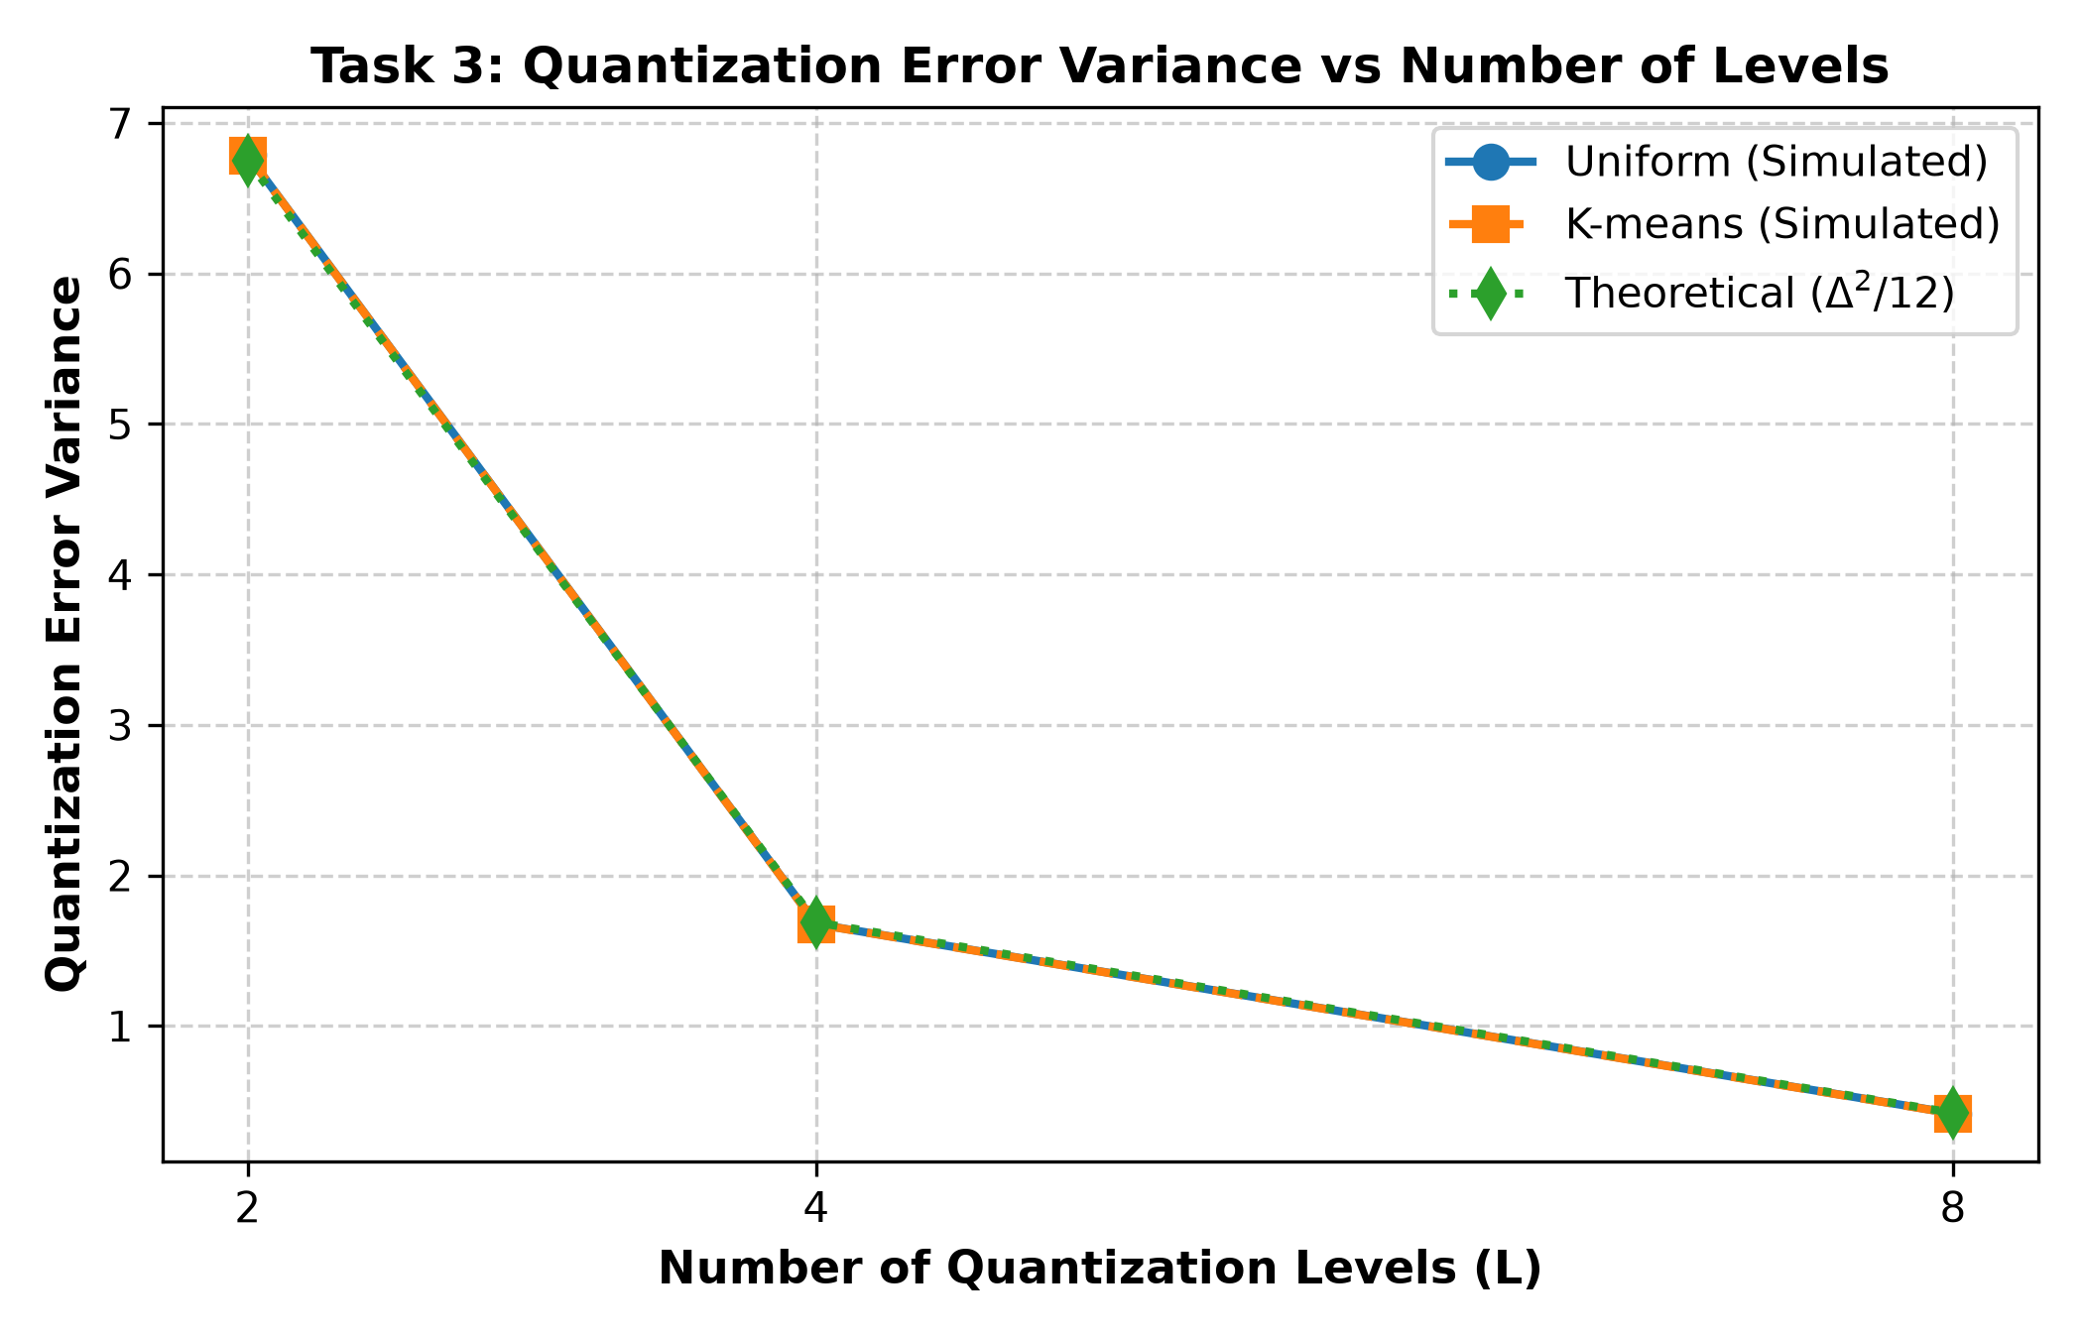
Figure 2: Quantization Error Variance vs. Number of Levels.
Performance Comments (Task 3):
1. Quadratic Drop: As L doubles, the error variance decreases by a factor of 4 (75% drop) because variance is proportional to Δ² (and Δ ∝ 1/L).
2. Theoretical Agreement: The simulated variances for both quantizers track the theoretical curve (Δ²/12) with minimal random deviation.

5. Task 4: Signal-to-Quantization-Noise Ratio (SQNR)
SQNR is defined as 10*log10(P_signal / P_noise) in dB. With P_signal = a^2 / 3 and P_noise = a^2 / (3*L^2), the theoretical formula simplifies to SQNR_theory = 20*log10(L) dB.
Levels (L) | Resolution (Bits) | Simulated Uniform SQNR | Simulated K-means SQNR | Theoretical SQNR
L = 2 | 1 bit | 5.97 dB | 5.97 dB | 6.02 dB
L = 4 | 2 bits | 12.04 dB | 12.04 dB | 12.04 dB
L = 8 | 3 bits | 18.07 dB | 18.06 dB | 18.06 dB

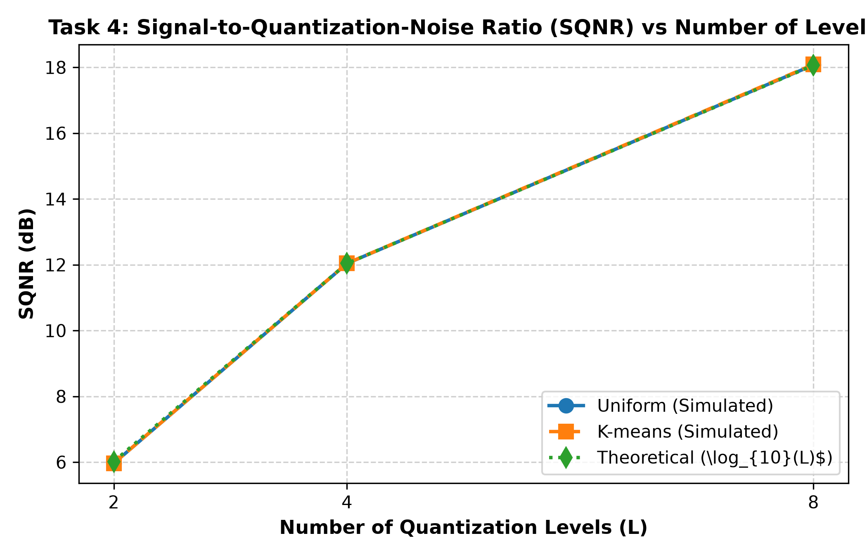
Figure 3: SQNR (dB) vs. Number of Levels.
Performance Comments (Task 4):
1. The 6.02 dB/bit Rule: In digital communications, every additional bit of resolution doubles the number of levels and increases SQNR by approximately 6.02 dB. Our simulation verifies this rule: 1 bit yields ~6 dB, 2 bits ~12 dB, and 3 bits ~18 dB.
2. High Fidelity: Both quantizers match theoretical SQNR perfectly.

6. Discussion: Comparison of the Two Approaches
1. How Levels are Determined:
• Uniform Quantizer: The boundaries and reconstruction levels are determined analytically before observing the data. The entire signal range [-a, a] is divided into L equal segments with step size Δ = 2a/L. The decision thresholds are fixed at -a + k*Δ, and the quantization levels are the exact arithmetic centers: -a + (k - 0.5)*Δ.
• K-means Quantizer: This is an iterative machine-learning algorithm (implementing the Lloyd-Max algorithm). It determines levels from the actual sample data by minimizing total squared Euclidean distance. It repeatedly applies two rules:
a. Nearest Neighbor Condition: Each sample is assigned to the nearest centroid.
b. Centroid Condition: Each centroid is updated to the arithmetic mean of all samples assigned to it.
2. Why Both Techniques Give Identical Performance Here:
Because the input signal is uniformly distributed over [-9, 9], the probability density function is constant. Under a flat distribution, the optimal Lloyd-Max centroids are mathematically equidistant midpoints. Therefore, K-means naturally converges to the exact uniform quantization levels.
3. Behavior on Non-Uniform Signals (e.g., Gaussian or Speech):
If the input signal followed a Gaussian or Laplacian distribution, samples would be heavily concentrated near zero with rare outliers at the extremes. A uniform quantizer would waste levels on the empty outer regions, resulting in high quantization noise in the dense center. In contrast, K-means would automatically place many closely spaced centroids near zero and very few at the tails. This data-adaptive clustering minimizes mean squared error and achieves significantly higher SQNR than uniform quantization on non-uniform signals.

7. Appendix: MATLAB Source Code (Mazen_Altelbany.m)
% Communication Theory - Assignment 1
% Group Members:
% 1. Mazen Altelbany (64-12371)
% 2. Suhad Eyhab Rasheed (64-31506)
% 3. Sama Ismael Ahel (64-19880)
clear;
clc;
close all;
% Max digit across IDs is 9 -> range [-9, 9]
a = 9;
N = 10000;
rng(42);
% Generate uniform signal
x = -a + 2 * a * rand(N, 1);
P_sig = mean(x.^2);
levels = [2, 4, 8];
numCases = length(levels);
mae_u = zeros(1, numCases);
mae_k = zeros(1, numCases);
var_u = zeros(1, numCases);
var_k = zeros(1, numCases);
var_th = zeros(1, numCases);
sqnr_u = zeros(1, numCases);
sqnr_k = zeros(1, numCases);
sqnr_th = zeros(1, numCases);
for i = 1:numCases
L = levels(i);
delta = (2 * a) / L;
% Uniform Quantizer
levels_u = -a + ((1:L) - 0.5) * delta;
idx_u = floor((x - (-a)) / delta) + 1;
idx_u(idx_u > L) = L;
idx_u(idx_u < 1) = 1;
x_q_u = levels_u(idx_u);
x_q_u = x_q_u(:);
% K-means Quantizer
[idx_k, centers_k] = kmeans(x, L, 'Replicates', 3);
x_q_k = centers_k(idx_k);
% Task 1: First 6 elements
fprintf('\n--- L = %d ---\n', L);
disp('First 6 original samples:');
disp(x(1:6)');
disp('First 6 Uniform quantized:');
disp(x_q_u(1:6)');
disp('First 6 K-means quantized:');
disp(x_q_k(1:6)');
% Quantization error
e_u = x - x_q_u;
e_k = x - x_q_k;
% Task 2: MAE
mae_u(i) = mean(abs(e_u));
mae_k(i) = mean(abs(e_k));
fprintf('MAE -> Uniform: %.4f | K-means: %.4f\n', mae_u(i), mae_k(i));
% Task 3: Variance
var_u(i) = var(e_u);
var_k(i) = var(e_k);
var_th(i) = (delta^2) / 12;
fprintf('Variance -> Uniform: %.4f | K-means: %.4f | Theory: %.4f\n', var_u(i), var_k(i), var_th(i));
% Task 4: SQNR
sqnr_u(i) = 10 * log10(P_sig / mean(e_u.^2));
sqnr_k(i) = 10 * log10(P_sig / mean(e_k.^2));
sqnr_th(i) = 20 * log10(L);
fprintf('SQNR (dB) -> Uniform: %.2f | K-means: %.2f | Theory: %.2f\n', sqnr_u(i), sqnr_k(i), sqnr_th(i));
end
% Figures
figure(1);
plot(levels, mae_u, '-o', levels, mae_k, '--s', 'LineWidth', 1.5);
grid on;
xlabel('Number of Levels (L)');
ylabel('MAE');
title('Mean Absolute Error vs Levels');
legend('Uniform', 'K-means');
xticks(levels);
saveas(gcf, 'task2_mae_vs_levels.png');
figure(2);
plot(levels, var_u, '-o', levels, var_k, '--s', levels, var_th, ':d', 'LineWidth', 1.5);
grid on;
xlabel('Number of Levels (L)');
ylabel('Variance');
title('Quantization Error Variance vs Levels');
legend('Uniform', 'K-means', 'Theory');
xticks(levels);
saveas(gcf, 'task3_variance_vs_levels.png');
figure(3);
plot(levels, sqnr_u, '-o', levels, sqnr_k, '--s', levels, sqnr_th, ':d', 'LineWidth', 1.5);
grid on;
xlabel('Number of Levels (L)');
ylabel('SQNR (dB)');
title('SQNR vs Levels');
legend('Uniform', 'K-means', 'Theory', 'Location', 'southeast');
xticks(levels);
saveas(gcf, 'task4_sqnr_vs_levels.png');

